Project CM

Version 1.0

Revision History

|  |  |  |  |
| --- | --- | --- | --- |
| **Date** | **Version** | **Description** | **Author** |
| 17/Oct/2013 | 1.0 | Initial UC description | Storm Cloud Development |
|  |  |  |  |
|  |  |  |  |
|  |  |  |  |

Table of Contents

1. Use-Case Name 4

1.1 Brief Description 4

2. Flow of Events 4

2.1 Screen Flow 4

2.2 Use Case Flows 5

2.2.1 Show all contacts (List View) 5

2.2.2 Show single contact (View Single) 5

2.2.3 Create new contact (Create) 6

2.2.4 Edit contact (Edit) 7

2.2.5 Delete contact (Delete) 8

3. Special Requirements 9

4. Preconditions 9

4.1 Database 9

5. Postconditions 9

5.1 Database 9

6. Extension Points 9

# Use-Case Name

## Brief Description

This Use-Case describes how a user can manage his personal address book. The user has the possibility to view a list of his contacts. Starting from this view the user is able to view a single entry, create a new entry, edit existing entries or delete old entries.

# Flow of Events

## Screen Flow

The picture shows the screen flow of the CRUD for managing the address book. The functions work on a contact in the address book.

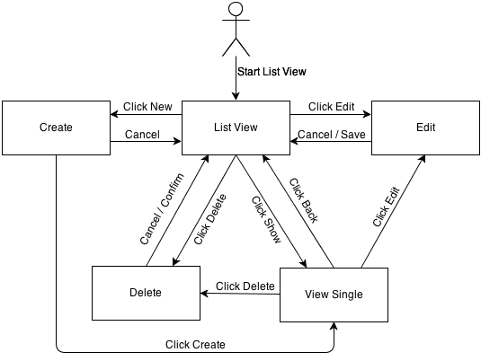

## Use Case Flows

### Show all contacts (List View)

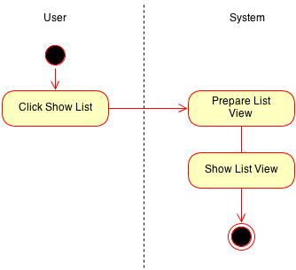

### Show single contact (View Single)

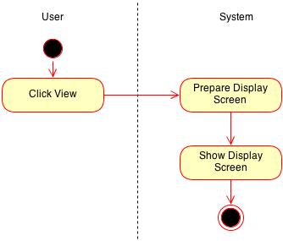

### Create new contact (Create)

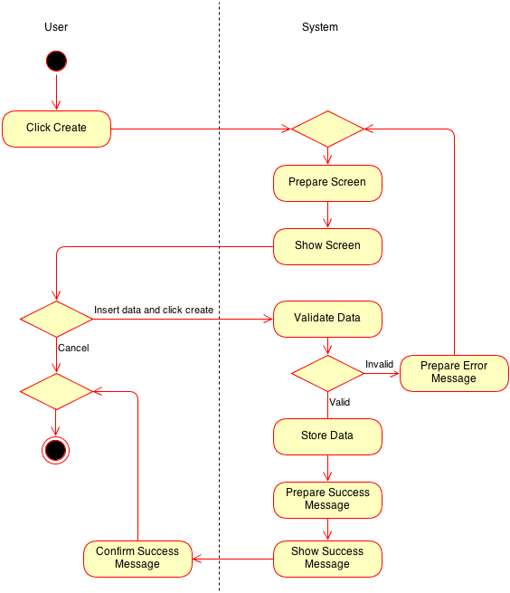

### Edit contact (Edit)

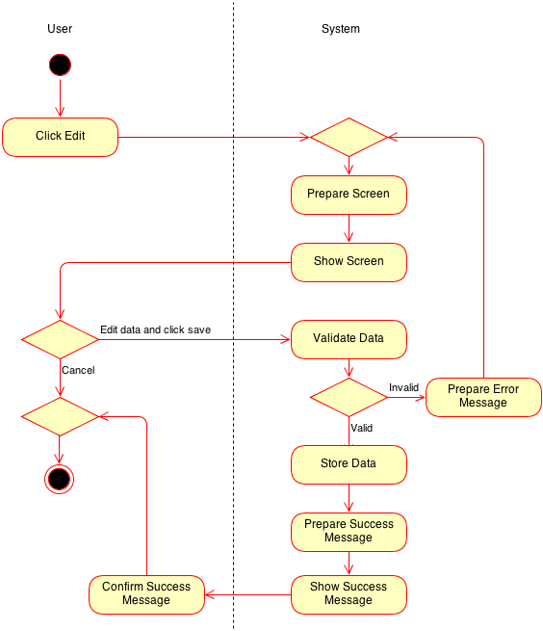

### Delete contact (Delete)

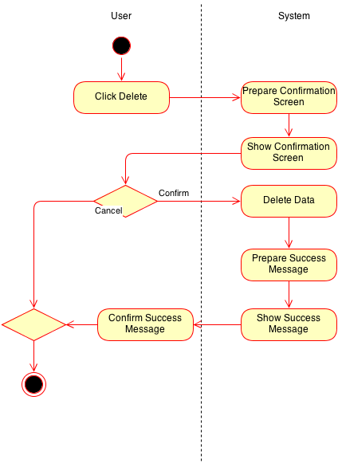

# Special Requirements

n/a

# Preconditions

## Database

Create: The entry to be created does not exist in the database.

Edit/view/delete: The entry has to be found in the database.

# Postconditions

## Database

Create: The entry to be created does now exist in the database.

Edit: The entry is updated.

Delete: The entry is deleted from the database.

# Extension Points

n/a